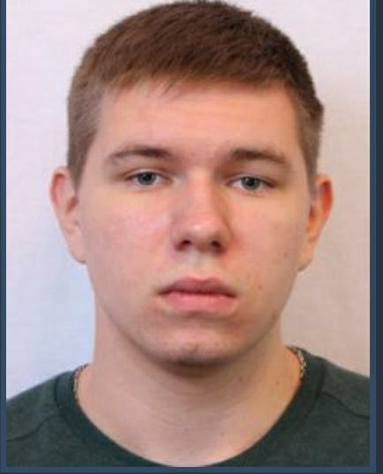

Software Developer

To obtain a challenging entry-level position in the field of computer science that allows me to utilize my knowledge and skills to contribute to the development of cutting-edge technology.

Tech Stack

|  |  |
| --- | --- |
| * Project management * Strong decision maker * Complex problem solver | * Creative design * Innovative * Service-focused |

Skills & Qualifications

|  |  |
| --- | --- |
| * Extensive knowledge in API & Database Design. * Experience in designing and configuring system applications. | * Skill in installing web applications using AI technology. * Flexible depending on task. |

Education

Bachelor of Science in Computer Science: **National Aerospace University «Kharkiv Aviation Institute»** 09/2018 – 07/2022

**Ukraine,** Kharkiv

Certifications

**SoftServe IT Academy -** Java. Essentials Crash Course12/2021

* OOP Concepts of Java, Java Inheritance, Polymorphism, Abstraction, Encapsulation
* Maven, JDBC, Docker, Postgree, SpringBoot
* SOLID Principles

Mykyta Poberezhnik

+380(50)-65-44-614

thelesnikgood@gmail.com

https://www.linkedin.com/in/mykyta-poberezhnik